Step 1: Create React App
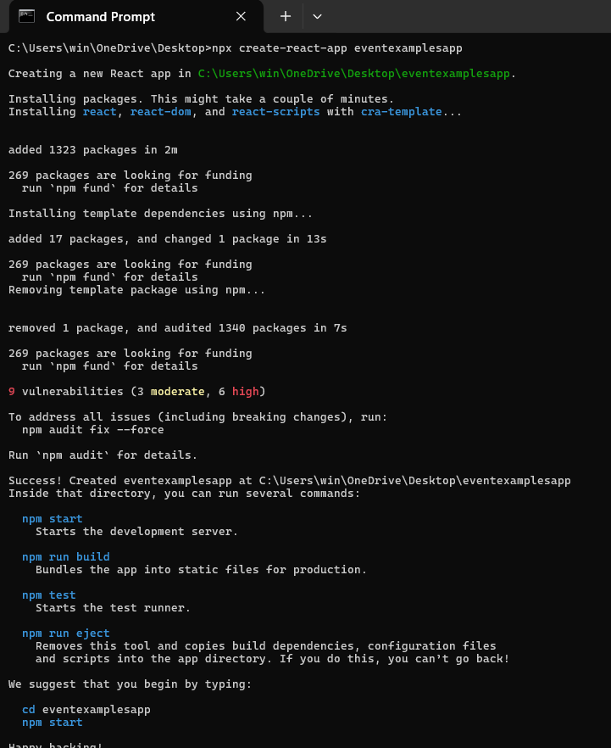

Step 2: Create Counter with Increment & Decrement
In src/Counter.js:
import React, { useState } from 'react';

function Counter() {
const [count, setCount] = useState(0);

const increment = () => {
sayHello();
setCount(count + 1);
};

const decrement = () => {
setCount(count - 1);
};

const sayHello = () => {
alert('Hello! Counter incremented!');
};

return (
<div>
<h2>Counter: {count}</h2>
<button onClick={increment}>Increment</button>
<button onClick={decrement}>Decrement</button>
</div>
);
}

export default Counter;

Step 3: Create Say Welcome Button with Argument
In src/SayWelcome.js:
import React from 'react';

function SayWelcome() {
const greet = (message) => {
alert(message);
};

return (
<button onClick={() => greet('Welcome!')}>
Say Welcome
</button>
);
}

export default SayWelcome;

Step 4: Handle Synthetic Event
In src/SyntheticEvent.js:
import React from 'react';

function SyntheticEvent() {
const handleClick = (e) => {
e.preventDefault();
alert('I was clicked');
};

return (
<button onClick={handleClick}>
OnPress
</button>
);
}

export default SyntheticEvent;

Step 5: Create CurrencyConvertor (INR to Euro)
In src/CurrencyConvertor.js:
import React, { useState } from 'react';

function CurrencyConvertor() {
const [rupees, setRupees] = useState('');
const [euros, setEuros] = useState('');

const handleSubmit = (e) => {
e.preventDefault();
const result = parseFloat(rupees) / 90; // example conversion rate
setEuros(result.toFixed(2));
};

return (
<div>
<h3>Currency Convertor</h3>
<form onSubmit={handleSubmit}>
<input
type="number"
placeholder="Enter amount in INR"
value={rupees}
onChange={(e) => setRupees(e.target.value)}
/>
<button type="submit">Convert</button>
</form>
{euros && <p>Euros: €{euros}</p>}
</div>
);
}

export default CurrencyConvertor;

Step 6: Import Components in App
In src/App.js:
import React from 'react';
import Counter from './Counter';
import SayWelcome from './SayWelcome';
import SyntheticEvent from './SyntheticEvent';
import CurrencyConvertor from './CurrencyConvertor';

function App() {
return (
<div className="App">
<h1>React Events Hands-On Lab</h1>
<Counter />
<SayWelcome />
<SyntheticEvent />
<CurrencyConvertor />
</div>
);
}

export default App;

Step 7: Run the Project

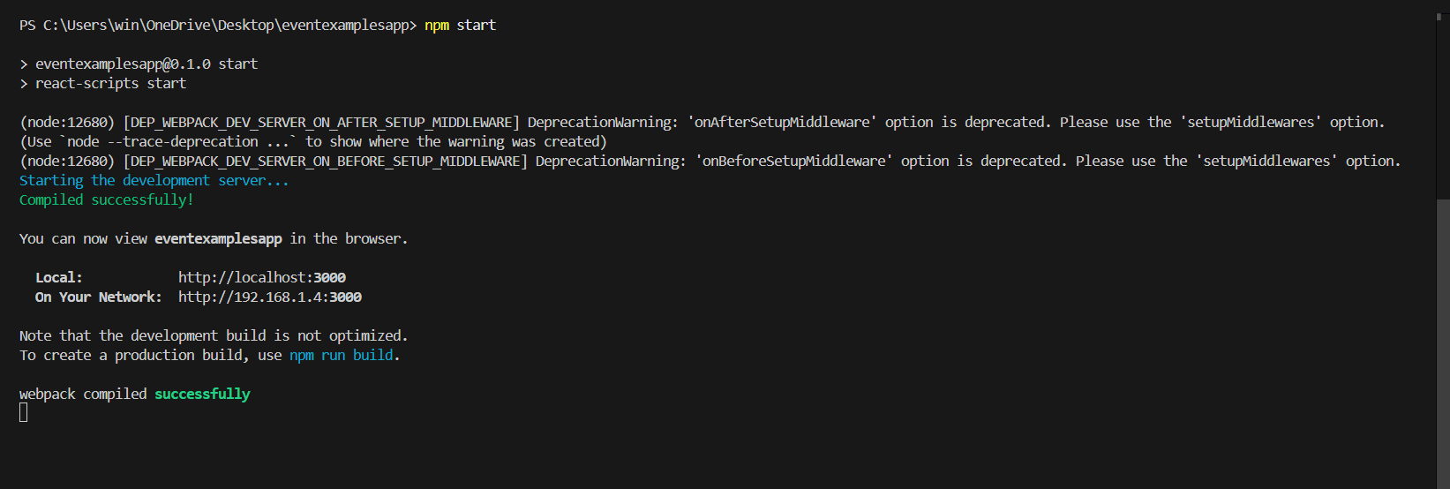

Step 8: Output

